  - Smart Parking Platform: Vision and Scope Document
Organization: Software Corp

Author: Emmanuel Perez
Course: CIS 4374
Table of Contents
1. Vision and Scope iv
1.1 Project Overview iv
1.2 Business Need iv
1.3 Existing Software iv
1.4 Competition Analysis v
1.5 Product Differentiation v
2. Software Requirements Specification vi
2.1 Purpose vi
2.2 Scope vi
2.3 Overall Description vi
2.3.1 User Groups vi
2.3.2 System Environment vii
2.3.3 Constraints vii
2.3.4 Assumptions vii
2.4 Functional Requirements vii
2.5 Non-Functional Requirements viii
2.6 Use Cases viii
2.6.1 Driver / Vehicle Owner Use Cases viii
2.6.2 Parking Facility Manager Use Cases xii
3. Work Breakdown Structure xiii
3.1 Purpose xiii
3.2 Smart Parking Platform WBS xiii
3.3 Story Point Estimation xiv
4. Timeline and Gantt chart xvi
5. Scrum Planning xvi
5.1 Product Backlog xvi
5.2 Sprint 1 Planning xviii
6. Risk and Communication Management xx
6.1 Project Risks xx
6.2 Risk Register xxi
6.3 Communication Plan xxii

1. Vision and Scope

1.1 Project Overview
Software Corp. is a fictitious Software development company responsible for the planning and development of the Smart Parking Platform. The Smart Parking Platform is a software system designed to assist drivers in locating, reserving and paying for open and available parking spaces in real time. Smart Parking will be accessible through both mobile and web applications and will provide users with information regarding parking availability and assistance with navigating to desired parking locations. The platform will also support parking facility managers with tools that help them track parking occupancy and pricing and improve the overall management of their facilities.

1.2 Business Need
Drivers often spend a significant amount of time searching for available parking. This can lead to an increase in traffic buildup and create frustration for drivers. It can also lead to lost productivity. At the same time, parking facility managers need better tools to help them monitor parking occupancy and improve how their available spaces are being utilized.
The Smart Parking Platform is designed with the intention of addressing these problems and resolving them by providing drivers with real-time parking information. The platform will also give parking facility managers better tools to manage their facilities more efficiently. By supporting both drivers and facility managers, this system can help improve the overall parking experience without excluding anyone.

1.3 Existing Software
The parking software market includes several applications that can be used to assist drivers with finding and paying for parking. Every parking application serves the same intended purpose but each approach parking differently, providing features that can be compared to the Smart Parking Platform. Three popular competitors I have found are ParkHouston, Spot Hero, and ParkWhiz.
ParkHouston is a mobile parking application used locally in the City of Houston, and it is powered by ParkMobile. This parking application allows users to pay for parking through their mobile device by entering the parking zone number shown on nearby signs or parking meters. The application also allows users to extend an active parking session or receive notifications when their session is close to expiring. ParkHouston mainly supports metered and on street parking.
SpotHero is a parking reservation platform that allows drivers to search for parking at garages and lots before arriving at their destination. The platform allows users to compare other parking options, serve spaces, and pay for their reservation through their web and mobile platforms. SpotHero also provides hourly, monthly, and airport/event parking. Widely considered to be the best for parking.
ParkWhiz is another parking reservation platform, like SpotHero, that allows drivers to search for nearby garages and parking lots. This platform gives users the ability to search and compare parking spaces and prices, reserve them and pay for them through both their web and mobile platforms. ParkWhiz also provides parking passes that can be used when arriving at the selected parking facility.

1.4 Competition Analysis
Competitor | Primary Focus | Pros | Cons
ParkHouston | Local street and metered parking | Easy mobile payment process.  Ability to extend parking sessions.  Great for finding parking in the Houston area. | Less focused on garage parking.  ParkHouston is mobile only.  Feels very limited to only Downtown/Mid town areas of Houston.
SpotHero | Advance parking reservations | Provides large selection of garages and lots.  Provides price comparisons.  Allows web and mobile booking for parking. | Reservation may not always be available upon arrival.  Many complaints over garage access issues.  Refunding process is tedious and difficult.
ParkWhiz | Parking reservations for garages and lots | Allows web and mobile parking.  Mobile Parking passes for events.  Advance reservations. | Users report extra hidden fees.  Difficulties in receiving refunds.  Reserved Parking being unavailable upon arrival
Most of the cons identified in this comparison are based on user feedback and reviews from Trustpilot.com.
Overall, the three platforms provide many useful parking options, but they also come with their limitations. ParkHouston is more focused on street and meter parking while SpotHero and ParkWhiz prioritize more lot and garage parking. Feedback provided by users of those applications also show that reservation availability and refund issues can also create problems for customers.

1.5 Product Differentiation
The breakdown of current parking applications shows several areas where the Smart Parking Platform can excel in and offer a better experience for users. Unlike ParkHouston, the Smart Parking Platform will not be limited mainly to street and meter parking. The platform will support all different types of parking including street, lot, and garage parking and will also be accessible through both web and mobile platforms.
The Smart Parking Platform will also focus heavily on providing real time parking availability. One of the common issues found in reserve parking platforms, like SpotHero and ParkWhiz, is that reserved parking is not always honored, and customers do not find out until they arrive. The Smart Parking Platform will address this by using current occupancy information so that we can give users a more accurate view of parking availability before they make a reservation.
The Smart Parking Platform will also improve communication between the driver and managerial sides of the system. By using real time occupancy, the information gathered will be used to keep the parking availability shown to drivers will be more closely aligned with the current capacity and availability status of each parking facility. This will be used to reduce situations where users make a reservation based on outdated or inaccurate availability levels.

2. Software Requirements Specification

2.1 Purpose
The purpose of this Software Requirements Specification is to outline the initial requirements for the Smart Parking Platform This section explains what the Smart Parking Platform is expected to do and what should be considered during the platform’s development. The requirements will also serve as a kick starter for the project and will continue to be expanded as the project progresses throughout the semester.

2.2 Scope
The Smart Parking Platform will provide both a web and mobile system that allows drivers to locate parking availability in real time. Users of this platform will be able to reserve and pay for their desired parking spaces through the platform. The system will also provide navigation assistance, if needed, to help users reach their selected parking locations.
In addition to the driver-focused features, the Smart Parking Platform will also help parking facility managers with tools that support the management of their facilities. These tools will help monitor parking occupancy and provide information that can be used to manage parking facilities more effectively. The platform will also connect with external services that can support functions such as navigation and payment processing when needed.

2.3 Overall Description
The Smart parking Platform is expected to be used by several types of users through both mobile and web applications. Some features of the platform will also rely on external services in order to function as intended. The following subsections explain who will be using the platform, where it will operate, and the main constraints or assumptions that may affect the project.

2.3.1 User Groups
The Smart Parking Platform will support multiple user groups. The primary users of this platform will be drivers and vehicle owners who use this platform to search for available parking spots and manage their reservations whether it be through the web or mobile.
Parking Facility managers will use the administrative side of the platform to help oversee and manage any parking activity happening in their facilities. System admins will help manage and support the operation of the platform as well.
Other stakeholders may also interact with or depend on the system as well. These can include city transportation departments, finance and billing personnel, and third-party payment providers. Their involvement may lead to any additional requirements as the project develops.

2.3.2 System Environment
The Smart Parking Platform will operate through both web and mobile applications. Users of this platform will be able to access the system through a mobile application or through the web. Most features for this platform will be available through both environments like searching for parking, viewing the availability of locations, making reservations, and managing account information. Navigation features will be mobile application only because users will need a mobile device while they drive to their reserved or selected parking location.

2.3.3 Constraints
The Smart Parking Platform will be developed within a fixed semester timeline. Although the project assumes an unlimited development budget, the system will highly depend on third-party services and APIs for certain features. These outside dependencies may affect how some functions of the platform are planned and will be implemented.
The Smart Parking Platform must also comply with applicable security and privacy requirements. City ordinances and other applicable laws must be considered when planning the operation of the system.

2.3.4 Assumptions
It is assumed that users will have access to a stable internet connection while using the Smart Parking Platform. The platform will rely on this connection to provide real-time parking information and access from outside services when needed. It is also assumed that these outside services will remain available and compatible with the platform throughout its operation.

2.4 Functional Requirements
The Smart Parking Platform should provide the following functional requirements:
- User Registration and Authentication
- The system should allow users to create an account and register their vehicle information into the platform.
- Real-time Parking Availability
- The system should allow users to view parking availability and traffic in real time.
- Interactive Parking Map
- The system should provide an interactive map that users can use to see available parking locations.
- Parking Reservations
- Users of the platform should be allowed to reserve an available parking space through the platform.
- Digital Payments
- Users should be able to complete payments for parking reservations through the platform.
- Reservation History and Receipts
- Users should be allowed to view previous reservations and access any payment receipts.
- Parking Facility Management
- The system should provide parking facility managers with an administrative dashboard to monitor and manage parking activity.
- Occupancy Reporting
- The system should provide parking facility managers with reports and information regarding parking occupancy.
- Notifications and Alerts
- The system should provide users with notifications and alerts related to their parking activity such as reservation confirmations and expirations.
- Navigation Integration
- The system should connect and work with external navigation services to help users reach their desired parking destinations.

2.5 Non-Functional Requirements
The Smart Parking Platform should meet the following nonfunctional requirements:
- Security
- The system should protect users’ information and payment data from unauthorized access.
- Availability
- The platform should remain available to users when they need to search for parking, manage reservations, or complete payments.
- Performance
- The system should respond quickly when users search for parking availability or access other features of the platform.
- Usability
- The web and mobile applications should be easy to understand and allow users to navigate the platform without any difficulty.
- Connectivity
- The platform will require an internet connection to access real-time parking information and be effective with outside services.
- Scalability
- The platform should be able to support an increasing number of users and parking facilities as the system grows

2.6 Use Cases

2.6.1 Driver / Vehicle Owner Use Cases

2.6.1.1 Create an Account
Actor: Driver / Vehicle Owner
Precondition: User does not already have an account with the Smart Parking Platform
Steps:
- The user enters web or mobile application and selects the “sign up” option.
- The user then enters the required personal information for account.
- The user then creates login credentials.
- The user then submits the registration information.
- The system creates the account and confirms that user registration was successful.
Postcondition: The user now has an active account on the Smart Parking Platform and can log in to access the platform.

2.6.1.2 Log In to Account
Actor: Driver / Vehicle Owner
Precondition: User has previously created an account with the Smart Parking Platform
Steps:
- The user opens the login page.
- The user enters their login credentials.
- The system verifies the information entered.
- The system grants the user access if the credentials are correct.
Postcondition: The user is logged in and can access the features available to their account

2.6.1.3 Register Vehicle Information
Actor: Driver / Vehicle Owner
Precondition: User is logged into their Smart Parking Platform account.
Steps:
- The user opens the vehicle information section.
- The user selects “add new vehicle” option.
- The user enters the required vehicles information such as the license plate, make, model, and color.
- The user submits the vehicle information.
- The system saves the vehicle to the user’s account.
Postcondition: The user’s vehicle information is now stored and connected to their account.

2.6.1.4 Search for Available Parking
Actor: Driver / Vehicle Owner
Precondition: The user is logged in to the Smart Parking Platform and is looking for available parking closest to their destination.
Steps:
- The user enters a desired parking location or destination in the search option.
- The system begins to search for the nearest available parking to the selected location.
- The system displays options sorted by distance (closest to furthest) for the user to choose from.
- The user looks through the options displayed.
Postcondition: The user is shown available parking options near the desired location.

2.6.1.5 View Parking Locations on Map
Actor: Driver / Vehicle Owner
Precondition: The user is logged in to the Smart Parking Platform and has enabled location services.
Steps:
- The user opens the Smart Parking Platform.
- The system displays the interactive parking map as the main screen.
- The system uses the user’s current location to display nearby parking locations.
- The user can navigate around the interactive map to view nearby parking.
- The user may select a parking location to get more information.
Postcondition: The user can view nearby parking locations based on their current location and select a location for more details.

2.6.1.6 View Parking Space Availability
Actor: Driver / Vehicle Owner
Precondition: The user has selected a parking location from the map
Steps:
- The system opens the selected parking location.
- The system displays the current parking availability for that location.
- The user reviews the available parking spaces and the number of open spaces.
- The user decides whether to continue with a reservation or to look elsewhere.
Postcondition: The user can view the current parking availability for the selected location.

2.6.1.7 Reserve a Parking Space
Actor: Driver / Vehicle Owner
Precondition: The user is logged in to the Smart Parking Platform and has selected a parking location with available parking.
Steps:
- The user selects the option to reserve a parking space.
- The system displays the reservation details.
- The user reviews the reservation information.
- The user confirms the reservation.
- The system saves the reservation and displays a confirmation message.
Postcondition: The parking space is now reserved for the user and the reservation is added to their account.

2.6.1.8 Cancel a Parking Reservation
Actor: Driver / Vehicle Owner
Precondition: The user is logged in and has an active parking reservation.
Steps:
- The user opens their current reservations.
- The user selects the reservation they want to cancel.
- The system displays the reservation details.
- The user selects the option to cancel the reservation.
- The system asks the user to confirm the cancellation.
- The user confirms the cancellation.
Postcondition: The parking reservation is now canceled and the space becomes available again for other users.

2.6.1.9 Make a Parking Payment
Actor: Driver / Vehicle Owner
Precondition: The user is logged in and has selected a parking reservation that requires a payment.
Steps:
- The system displays the amount due for the reservation.
- The user selects a payment method.
- The user enters or confirms the required payment information.
- The user submits the payment.
- The system then processes the payment and displays the payment confirmation.
Postcondition: The payment is completed and the parking space is now reserved for the user.

2.6.1.10 View Reservation History
Actor: Driver / Vehicle Owner
Precondition: The user is logged in to the Smart Parking Platform
Steps:
- The user opens their account or reservation section.
- The user selects the option to view reservation history.
- The system displays the user’s previous parking reservations.
- The user may select a reservation to view more information.
Postcondition: The user can view their previous parking reservations and their details.

2.6.1.11 View Payment Receipt
Actor: Driver / Vehicle Owner
Precondition: The user is logged in and has previously made a payment through the Smart Parking Platform.
Steps:
- The user opens their reservation history.
- The user selects a reservation with payment.
- The user selects the option to view the payment receipt.
- The system displays the receipt and payment details.
Postcondition: The user can now view the payment receipt for the selected reservation.

2.6.1.12 Get Navigation Directions
Actor: Driver / Vehicle Owner
Precondition: The user is using the Smart Parking mobile application has selected their reserved parking location or a new one.
Steps:
- The user selects the option to get directions.
- The Smart Parking mobile application connects to an external navigation service such as maps or google maps.
- The selected parking location is transferred to the navigation service.
- The navigation service provides directions to the selected parking location.
Postcondition: The user can now begin driving to the selected parking location through their mobile device.

2.6.2 Parking Facility Manager Use Cases

2.6.2.1 View Parking Facility Dashboard
Actor: Parking Facility Manager
Precondition: The parking facility manager is logged into an authorized admin account.
Steps:
- The manager opens the administrative dashboard.
- The system displays information related to the manager’s parking facilities.
- The manager reviews the current parking activity and facility information.
- The manager may select different sections of the dashboard to view additional details.
Postcondition: The parking facility manager can view the status and activity of their parking facility.

2.6.2.2 Monitor Parking Occupancy
Actor: Parking Facility Manager
Precondition: The parking facility manager is logged in and has access to the administrative dashboard.
Steps:
- The manager opens the parking occupancy section.
- The system displays the current occupancy of the parking facility.
- The manager reviews the number of occupied and available parking spaces.
- The system updates the displayed occupancy information as new activity occurs in real time.
Postcondition: The parking facility manager can now monitor the current occupancy of the parking facility.

2.6.2.3 View Occupancy Reports and Analytics
Actor: Parking Facility Manager
Precondition: The parking facility manager is logged in and has access to the administrative dashboard.
Steps:
- The manager opens the reports and analytics section.
- The system displays available parking occupancy reports.
- The manager selects a report to review.
- The system displays the selected report and its related information.
Postcondition: The parking facility manager can review occupancy reports and analytics for the parking facility.

3. Work Breakdown Structure

3.1 Purpose
The purpose of this Work Breakdown Structure is to break down the Smart Parking Platform into smaller parts so that it can be more manageable. The WBS organizes the project into a three-level hierarchy that will help with estimating the work and creating the timeline.
The WBS will be formatted as shown below:
- Level 1 – Major System Component
- Level 2 – Module or Group within that component
- Level 3 – Specific feature within module or group

3.2 Smart Parking Platform WBS
1. User and Operator Management
1.1 Driver Account
1.1.1 Create User Account
1.1.2 User login and Authentication
1.1.3 Register vehicle information

1.2 Parking Facility Manager Account
1.2.1 Manager Account setup
1.2.2 Manager Authentication
1.2.3 Parking Location Profile Setup

2. Parking Search and Reservation
2.1 Parking Search and Map
2.1.1 Find Parking by destination
2.1.2 View Nearby Parking Locations
2.1.3 View Real Time Availability for Parking

2.2 Reservation Management
2.2.1 Reserving Parking Space
2.2.2 Cancel Reservation
2.2.3 View Reservation History

2.3 Navigation Functions
2.3.1 Select Parking Destination
2.3.2 Connection to External Mapping Services

3. Payment and Billing Services
3.1 Payment Processing
3.1.1 Select Payment Method (On Site or Online)
3.1.2 Process Parking Payment (if done beforehand)
3.1.3 Confirm Payment

3.2 Receipts and Payment History
3.2.1 Generating Receipt
3.2.2 View Payment Receipt

4. Parking Location Management and Facility Monitoring
4.1 Parking Location Management
4.1.1 Add Parking Location (Garage, Lot, Meter/Street)
4.1.2 Edit Location Information and Capacity
4.1.3 Remove Parking Location

4.2 Occupancy and Availability Monitoring
4.2.1 Connecting Parking Monitoring System (Cameras, Sensors, Plate Readers, etc.)
4.2.2 Update Availability
4.2.3 Display Current Occupancy

5. Dashboards and Reporting
5.1 Facility Manager Dashboard
5.1.1 View Current Occupancy Status
5.1.2 View Reservation Activity
5.1.3 View Financial Activity

5.2 Reports and Analytics
5.2.1 Generate Occupancy Report
5.2.2 Generate Financial Report
5.2.3 View Parking Activity Report

3.3 Story Point Estimation
Story points are used to estimate the relative difficulty, effort and risk of each level 3 item in a WBS. The Scale I will be using for my story point estimation is the Fibonacci Scale. This scale uses the values of 1, 2, 3, 5, 8, and 13, etc., with the higher values representing the work to be more difficult or require more work.
WBS ID | Level 3 Item | Story Points
1.1.1 | Create User Account | 3
1.1.2 | User login and Authentication | 5
1.1.3 | Register vehicle information | 3
1.2.1 | Manager Account setup | 3
1.2.2 | Manager Authentication | 5
1.2.3 | Parking Location Profile Setup | 5
2.1.1 | Find Parking by destination | 5
2.1.2 | View Nearby Parking Locations | 5
2.1.3 | View Real Time Availability for Parking | 8
2.2.1 | Reserving Parking Space | 8
2.2.2 | Cancel Reservation | 3
2.2.3 | View Reservation History | 3
2.3.1 | Select Parking Destination | 2
2.3.2 | Connection to External Mapping Services | 8
3.1.1 | Select Payment Method (On Site or Online) | 2
3.1.2 | Process Parking Payment (if done beforehand) | 8
3.1.3 | Confirm Payment | 3
3.2.1 | Generating Receipt | 3
3.2.2 | View Payment Receipt | 2
4.1.1 | Add Parking Location (Garage, Lot, Meter/Street) | 5
4.1.2 | Edit Location Information and Capacity | 3
4.1.3 | Remove Parking Location | 2
4.2.1 | Connecting Parking Monitoring System (Cameras, Sensors, Plate Readers, etc.) | 13
4.2.2 | Update Availability | 8
4.2.3 | Display Current Occupancy | 5
5.1.1 | View Current Occupancy Status | 3
5.1.2 | View Reservation Activity | 3
5.1.3 | View Financial Activity | 5
5.2.1 | Generate Occupancy Report | 5
5.2.2 | Generate Financial Report | 5
5.2.3 | View Parking Activity Report | 3

The value 13 was used as the highest value for my story points because the level 3 items in my WBS are already broken into smaller work packages. Items that would be estimated to be above that will likely be needed to be broken down further. Higher values of 8 and 13 were also given to features involving the use of real time data, outside systems, payment processing, or parking monitoring because these items require more complexity and effort to manage.

4. Timeline and Gantt chart
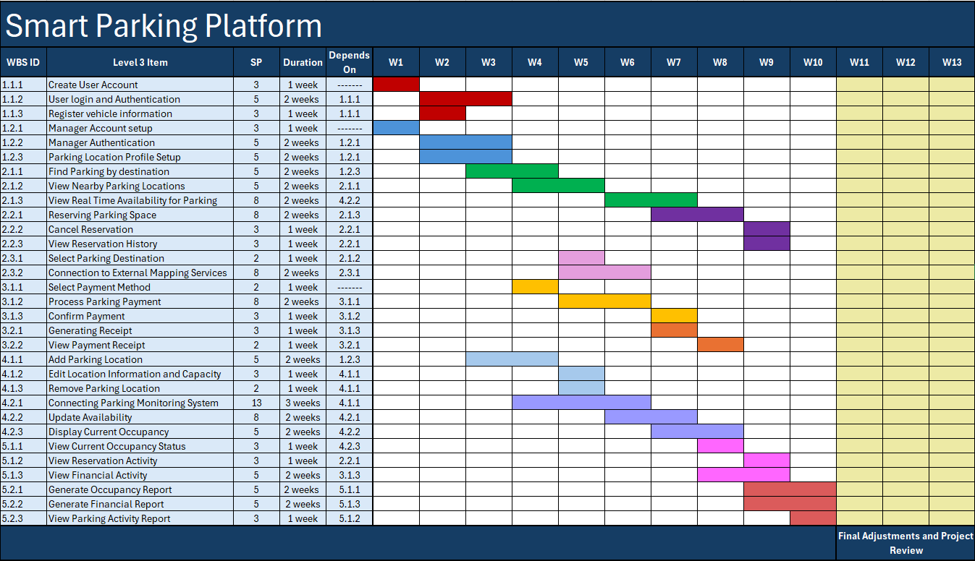
The Smart Parking Platform Project development is scheduled across a thirteen-week period that will follow the duration of the semester. The Gantt chart shows the planned duration including dependencies for each level 3 WBS item. Tasks that can be worked on at the same time are scheduled closer and overlapped while dependent tasks that require more work are placed later in the schedule.
The final 3 weeks of the project schedule will be reserved for final adjustments and review. This time will be used to address and fix any remaining issues, make any necessary changes, prepare the overall platform before deploying it to the public.

5. Scrum Planning

5.1 Product Backlog
The product backlog for the Smart Parking Platform project was created using Trello. The backlog contains the work items that may be completed throughout the project. It includes 45 items organized into four categories marked by labels. These categories are: Login, UI, Backend, and Reporting. Each item was added as a separate card and labeled based on each category.
Here is the backlog:
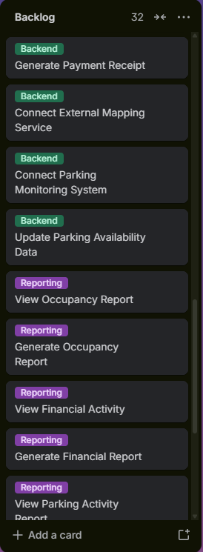
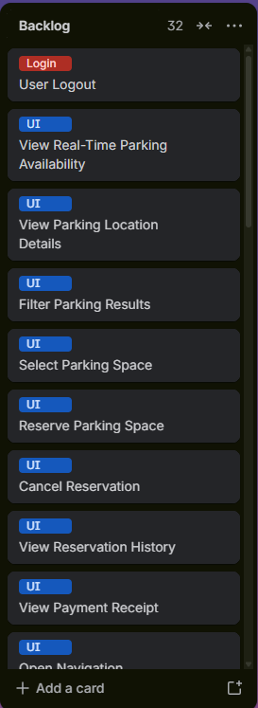
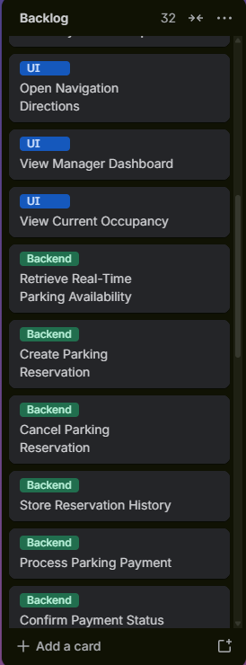
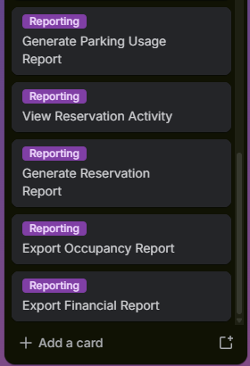

5.2 Sprint 1 Planning
Sprint 1 of the Platform Parking Project was created by selecting some items that would be considered a first priority from the overall backlog list. The first sprint focuses mainly on account setup, authentication, parking location setup and basic parking search features. These items were selected first because they provide the foundation needed for later features such as parking reservations, payment functions, real time availability features and reporting.
Here is the first sprint:
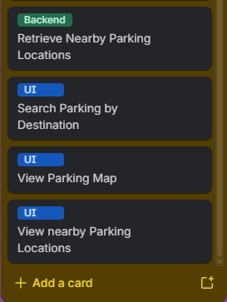
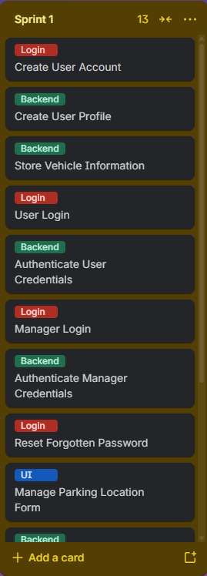

6. Risk Management & Communication Plan

6.1 Project Risks
The Smart Parking Platform may face several risks throughout its development and release to the public. These risks can be technical, financial, schedule, or even people risk. Spotting these risks early can help our team prepare for these risks and possibly reduce the chances of them happening or impacting our platform.
    - Technical Risks
ID | Risk Description
T1 | Real-time parking data may be inaccurate or delayed.
T2 | Parking sensors or cameras may fail to read plates or provide accurate/correct data.
T3 | External API services may fail in synchronizing information or connecting with our platform (mapping, navigating, payment processing third parties).
T4 | Network or server outages may prevent users from accessing live parking information or completing transactions.
    - Schedule Risks
ID | Risk Description
S1 | Integrating API from third party partners may take longer than expected.
S2 | Delays in earlier tasks may push back later features from being implemented or worked on.
S3 | Real-time parking features may take longer to test or not work at all, which would lead to a rework.
S4 | Sprint items may not be completed within their planned Sprint.
    - Financial Risks
ID | Risk Description
F1 | External APIs may cost more than expected.
F2 | Real-time parking sensors and monitoring equipment may use up more than the planned budget.
F3 | As the platform grows the cost to maintain servers and cloud infrastructures may increase.
F4 | Unexpected maintenance or additional features may create additional project expense.
    - People Risks
ID | Risk Description
P1 | An important developer or core team member leaves the project.
P2 | Poor communication amongst team which can cause mistakes.
P3 | Conflicts happening between team members.
P4 | A team member lacks the technical skills needed for a specific part of the project.

6.2 Risk Register
Out of the 16 risks identified for the Smart Parking Platform, the risk register focuses on the risks that should be monitored more closely throughout the project. Each risk is evaluated based on its probability of happening and the potential impact it has on this project. The register also includes the person responsible for monitoring the risk and the response strategy that will be used to handle that risk if necessary.
ID | Risk Description | Probability | Impact | Owner | Response Strategy | Notes
T1 | Real-time parking data may be inaccurate or delayed. | High | Major | Backend / Systems Lead | Mitigate | Monitor real-time data accuracy and compare reported availability with actual parking occupancy.
T2 | Parking sensors or cameras may fail to read plates or provide accurate/correct data. | Moderate | Major | Hardware / Integration Lead | Mitigate | Regularly test sensors and cameras and replace or repair failed equipment when needed.
T3 | External API services may fail in synchronizing information or connecting with our platform (mapping, navigating, payment processing third parties). | High | Major | Software Integration Lead | Mitigate | Test third-party APIs regularly and prepare backup options if a service becomes unavailable.
T4 | Network or server outages may prevent users from accessing live parking information or completing transactions. | High | Major | System Administrator / Infrastructure Lead | Mitigate | Monitor server performance and maintain backup and recovery procedures to reduce downtime.
S1 | Integrating API from third party partners may take longer than expected. | Moderate | Moderate | Project Manager | Mitigate | Begin API integration early and allow extra time for troubleshooting.
S2 | Delays in earlier tasks may push back later features from being implemented or worked on. | Moderate | Moderate | Project Manager / Scrum Master | Mitigate | Track task dependencies closely and adjust the schedule if earlier work begins to fall behind.
F2 | Real-time parking sensors and monitoring equipment may use up more than the planned budget. | High | Major | Project Manager / Finance Lead | Mitigate | Compare equipment costs from different vendors and review hardware needs before purchasing.
F3 | As the platform grows the cost to maintain servers and cloud infrastructures may increase. | Moderate | Major | Infrastructure Lead / Finance Lead | Mitigate | Monitor cloud and server usage regularly to avoid unexpected increases in operating costs.
F4 | Unexpected maintenance or additional features may create additional project expense. | Moderate | Moderate | Project Manager | Accept / Mitigate | Keep part of the budget available for maintenance, unexpected repairs, or approved additional features.
P1 | An important developer or core team member leaves the project. | Low | Moderate | Project Manager / Team Leader | Mitigate | Make sure other team members understand key responsibilities so work can continue if someone leaves.

6.3 Communication Plan
The communication plan for the Smart Parking Platform is designed to keep the project team, facility managers, investors and third-party partners informed throughout the entire development and deployment of the platform.
Audience / Group | Method | Frequency | Purpose
Project Team | Microsoft Teams | Daily | Quick updates, questions, task coordination, and urgent issues.
Project Team | In person meeting | Weekly | Review completed work, current progress, upcoming tasks, team concerns, and issues that need to be resolved.
Investors / Stakeholders | Email | Monthly / As needed | Provide project updates, major decisions, progress, and important concerns.
Investors / Finance Stakeholders | Email / Microsoft Teams | Biweekly | Review development spending, third-party service costs, and overall budget usage.
Third-Party Partners | Email | As needed | Coordinate services, APIs, equipment, and integration-related issues.
Investors / Third Parties | Microsoft Teams video meeting | As needed | Handle urgent matters that require immediate or more detailed discussion.
Parking Facility Managers / Operators | Email / Microsoft Teams | Biweekly / As needed | Gather feedback, review parking operations, discuss occupancy data, and address platform issues.
Customers | Email / In-app notifications / Surveys | As needed | Share major updates, collect feedback, and notify users of service changes or issues.

